

Website Content

August 2011

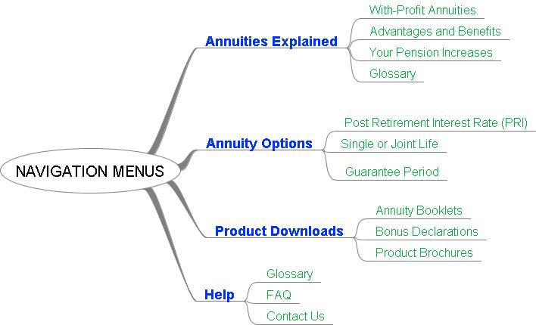

Hi Liam

Please use the above layout for the drop down toolbox as discussed. Whether on the side in the left/right column or on top below the tabs – please use what you see fit.

In the text below I have used legal numbering to guide you through the text – please don’t use the numbering on the website, thanks.

Could you also please change the fixed tabs to the following for now please?

**Home** *(Keep the log in box visible on each main page)*

**Information Toolbox**

**About Us**

**Contact Us**

# Annuities explained

## With-Profit Annuities

**What is a with-profit annuity?**

Your investment in Momentum’s with-profit annuity guarantees to pay you an income for the rest of your life, no matter how long you live. With-profit annuities also give you the opportunity of sharing in the future profits made by the fund and so your annuity income will potentially rise in future years.

The aim of our with-profit annuity is to provide as much income growth over time as possible by way of annual increases. Profits arise mainly from steady investment performance, but could also come from mortality experience.

## Advantages and Benefits

**The advantages of with-profit annuities**

* They pay a guaranteed income for life which will never decrease.
* Once an increase is awarded, it can never be taken away and the new higher income is guaranteed for life.
* They enable retired investors to maintain some exposure to fixed interest, property and equities.
* They provide the potential of a growing income with security and peace of mind.
* They smooth investment returns, ironing out investment peaks and troughs.
* In the longer term, with-profit annuities should provide protection against inflation.
* Retired investors can opt for their spouse to receive a pension when they pass away.
* With-profit annuities can also be guaranteed to be paid for a certain period of time. This means that if you pass away soon after investing, your nominated beneficiaries or estate will continue to receive income payments.

## Your Pension Increases

Your annual increase depends on the performance of the with-profit annuity investments together with our smoothing techniques and your chosen PRI*.

*NOTE: Post Retirement Interest Rate (PRI) is a choice you make and is described under your Annuity Options.*

**Smoothing your increases**

Your pension increases are not constant and can be higher or lower from year to year. At Momentum we understand the importance of stability when it comes to annuity investments and are therefore able to protect you from ups and downs in the market. This technique is called “smoothing”.

Smoothing simply means that strong or poor returns in any single year will be spread out over a few years. This ensures that your increases absorb uncertainty and remain stable.

The graph below shows how smoothing protects you against the ups and downs in a volatile market.

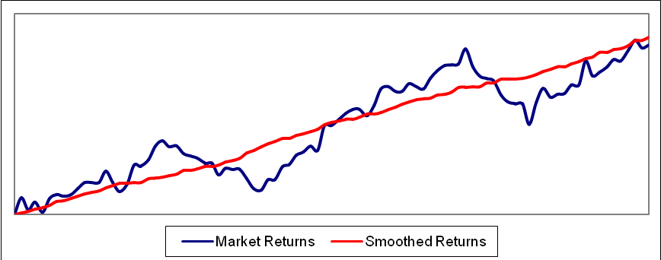

**Our investment policy**

Your pension assets are invested in a balanced fund with two aims in mind:

1. Generate as much profit as possible to provide you with as high an increase as possible.
2. Meet our guarantee to pay your income for as long as you live.

We also ensure that you get exposure to a wide variety of asset classes, in South Africa as well as abroad. Your annual increases are linked directly to the ongoing performance of the with-profit annuity balanced fund.

The chart below shows the strategic asset allocation we utilise for the with-profit annuity assets.



**Historical increases**

Over the past ten years very competitive pension increases have been awarded, helping to reduce the impact of inflation. Please refer to the product downloads section here for our historical increases.

Although our with-profit annuities do not guarantee that pension increases will meet inflation every year; Momentum still aims to reduce the impact of inflation over the longer term.

## Glossary

**Annuity** An agreement between an insurer and a policyholder whereby the insurer makes regular payments to the policyholder throughout the life of the consumer.

**Balanced Fund** A fund that has investments diversified over equities, bonds, property and money market instruments.

**Bonus rate** The net rate of return declared on the with-profit annuity assets from which annual increases are determined.

**Consumer Price Index (CPI)** An indicator used to monitor inflation, also referred to as the cost-of-living index.

**Guarantee period** The minimum period that you want your annuity to be paid out for certain. Should you pass away within the guarantee period, your annuity will continue to be paid to your nominated beneficiaries or estate.

**Inflation** A rise in the general price level of goods and services, which leads to decreasing purchasing power of the currency concerned.

**Insurer / insurance company** A company that agrees to pay the consumer an amount or amounts on the occurrence of an event that is defined in the contract with the policyholder.

**Investment profits / investment return** The money that has been made from an investment in assets. This can include growth in the value of an asset or dividends paid to the investor.

**Joint life annuity** An annuity that is payable to the annuitant and his/her spouse until both individuals have passed away. (Compare with Single life annuity)

**Mortality experience** See Mortality profits

**Mortality profits** A profit or loss incurred by the insurer as a result of differences in the actual length of policyholder lifetimes and the assumed length of such lifetimes. To provide an annuity for the life of policyholders, the insurer needs to make an assumption about the expected length of policyholder lifetimes.

**Post-retirement interest (PRI) rate** A rate that represents the minimum amount of investment profit or returns the portfolio underlying the with-profit annuity has to achieve to continue paying the current level of pension per year.

**Purchasing Power** The amount of goods or services that one unit of money can buy for the currency concerned. In general, inflation decreases the amount of goods or services you would be able to purchase.

**Single life annuity** An annuity that is payable only to the main member and the payments stop upon his/her death.

**Smoothing** A technique Momentum applies to investment profits in order to provide stable increases from one year to the next.

**Socially responsible investment (SRI)** One of the asset classes in our with-profit annuity assets. In order for an investment to be classified as an SRI it must meet a number of criteria, such as a business's commitment to black economic empowerment, addressing HIV/Aids in the workplace, labour policies and environmental practices.

**With-Profit Annuity** An annuity contract that allows policyholders to share in the profits made on the with-profit assets. This profit-sharing is done by way of future annual increases.

# Annuity options

At Momentum we understand the importance and value in allowing you to tailor your annuity income to meet your personal circumstances. There are potentially 3 important options you need to decide on when investing in our with-profit annuity.

## Post Retirement Interest Rate (PRI)

The PRI rate you choose will determine your starting annuity income and it will affect your future annual increases. The PRI can be seen as the upfront rate of future returns you want your starting annuity to take credit for. This is because only investment returns in excess of your PRI are available for your pension increases.

The higher the chosen PRI:

* The higher the starting level of income will be
* But the lower future increase will be.

The chart below shows how your annuity income may grow over time for two different PRI categories. Please note your actual future increases may differ to the chart below and that past performance is no guarantee of future results. Your own starting pension will depend on your particulars such as the amount available for investment; the options you choose; your age and sex.

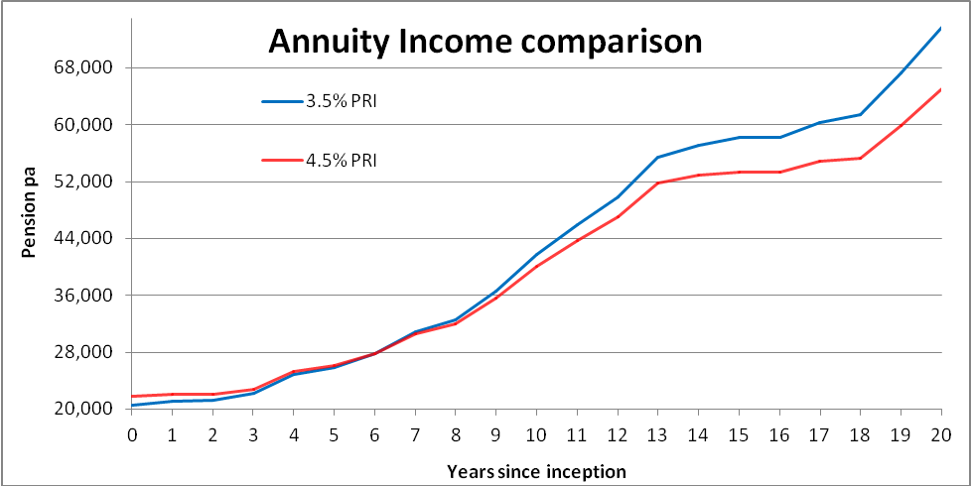

Your annual increase comes from the investment profits that remain after your PRI has been met.

Consider for example:

* Pensioner on 4% PRI
* Investment returns of 10%
* Then 4% of these returns will be used to maintain your current level of income
* The remaining 6% (10% - 4%) will be used to increase your pension.

It is only natural to want the highest PRI which gives the highest initial income, but you shouldn’t forget the effects of lower future increases which could erode your purchasing power. A with-profit annuity with a lower PRI will start lower, but it will potentially award higher increases in the future.

## Single or Joint Life

A single life annuity pays a higher level of income than a joint life annuity, but stops when you pass away (if no guarantee period was chosen).

If you choose a joint life annuity the pension payments will continue to your spouse or common-law partner if you pass away first. You can choose how much income your spouse will receive after you have died by selecting a spouse’s reversion %.

For example, a 75% spouse’s reversion means that when you pass away, your spouse will receive 75% of your pension for as long as they live.

## Guarantee Period

A guarantee period allows you to guarantee your annuity to be paid for a certain period of time. This means that if you pass away soon after investing, your nominated beneficiaries or estate will continue to receive income payments.

You can choose 5 or 10 year guaranteed periods or no guarantee at all. If you select a 5 year guarantee period and passed away after 3 years, your income will continue to be paid to your dependants for another 2 years. If you select a 10 year guarantee, the income payments would continue for another 7 years.

If you invested in our with-profit annuity without a guarantee period and died the day after, your income payments will stop and your family would get nothing (unless a joint life annuity was selected). It is important to note that in this scenario your investment will be shared as mortality profits and will be distributed to the other with-profit pensioners by way of enhanced increases. By choosing a guaranteed period you can protect yourself and your family against this rare event.

# Product downloads

## Annuity booklets

Available for download: Our with-profit annuities annual and interim feedback reports:

## Bonus Declarations

Every December, Momentum calculates the annual increase you will receive in the coming year by means of declaring a bonus.

**History of annuity increases**

|  |  |  |  |  |  |
| --- | --- | --- | --- | --- | --- |
| **Year** | **Bonus on with-profit annuities** | **Increase based on 3.5% pri** | **Increase based on 4% pri** | **Increase based on 4.5% pri** | **Inflation rate for previous year** |
| 2011* | 11.50% | 7.63% | 7.07% | 6.51% | 3.48% |
| 2010* | 9.20% | 5.41% | 4.86% | 4.31% | 6.33% |
| 2009* | 10.00% | 6.18% | 5.62% | 5.07% | 9.51% |
| 2008 | 14.50% | 10.63% | 10.00% | 9.38% | 8.98% |
| 2007 | 16.10% | 12.17% | 11.54% | 10.91% | 5.79% |
| 2006 | 13.50% | 9.66% | 9.04% | 8.42% | 3.6% |
| 2005 | 9.75% | 6.04% | 5.43% | 4.83% | 3.39% |
| 2004 | 3.00% | 0.00% | 0.00% | 0.00% | .33% |
| 2003 | 9.50% | 5.80% | 5.19% | 4.59% | 12.41% |
| 2002 | 11.86% | 8.08% | 7.46% | 6.85% | 4.59% |

**Note:**1. The bonus indicated in the table is net of the investment charge.  
2. Past investment performance is not a guarantee of future investment performance.  
3. The Golden Growth With-profit Annuity Bonus Series 1 was closed in June 2008. All new investments will flow into the Golden Growth With-profit Annuity Bonus Series 2.  
4. *The bonus for 2009, 2010 and 2011 is for Bonus Series 2.

**Downloads:**

Available for download: Our with-profit annuities annual bonus declarations.

## Product Brochures

Downloads:

# Help

## Glossary

Repeat of section 1.4

## FAQ

Will complete with possible screen shots as discussed.

## Contact Us

Momentum Employee Benefits contact centre:

0860 103 230 | 021 917 3111

Email:

[ebinvestmentadmannuities@metropolitan.co.za](mailto:ebinvestmentadmannuities@metropolitan.co.za)

Contact:  
Johann Swanepoel  
Head: Annuity Business  
Momentum Employee Benefits  
Parc du Cap  
Mispel Street  
Bellville   
7530